Online School Portal
https://students.ashworthcollege.edu/dashboard
Username: Carriegilles@ymail.com
Password: 133Pinson

Sign in
Click on Spanish 2: Part
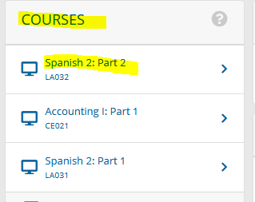

Click on Assessments
- Assignments
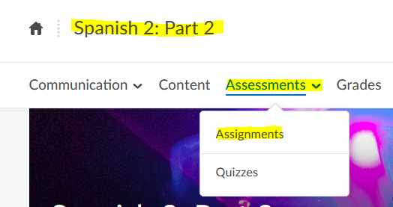

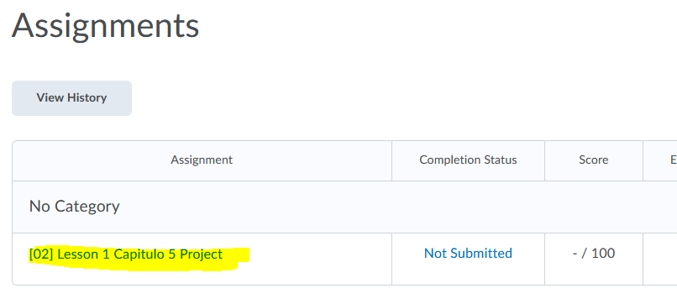

For all information needed on this Essay, it can be found on the portal
Under the Content tab

Requirements:
Write an essay, 1-2 paragraphs long and 10-15 sentences total. Make sure you write at least 5 sentences that answer all the items above. Be sure to use the 5 verb structures you have learned so far—reflexive verbs, present progressive verbs, present tense, preterite tense or imperfect verbs.
Remember the following:
* You MUST use vocabulary from the course and text to show me that you learned and mastered the material.
* Watch your grammar and tense in your sentences.
* Each sentence must have at least have a subject and verb. Remember to properly conjugate your verb in the correct tense and that subjects and verbs must agree, as well as nouns, adjectives and articles.
* Finally, it must be completely done in complete sentences in Spanish. Accent marks, tildes, and any upside down question marks or exclamation points also count towards your score.

Objective: An elementary bilingual teacher asks you to come to her class to talk to her students about how you used to celebrate the holidays with your family. First you want your Spanish teacher to hear what you plan to say, so you decide to write it out to read to her. Be sure to include:
- where you used to celebrate most family holidays
- what you used to do
- who got together with you to celebrate
- what your favorite family holiday was
- why it was your favorite family holiday
**If you do not celebrate holidays, then write your essay about a special event you used to enjoy with your family, like a vacation you took, a family tradition you used to honor, or a place you used to go to with your family. Use all of the same criteria in these instructions in your essay.

